# Softwarica College of IT & E-Commerce

**STW210CT: Programming, Algorithms and Data Structures**Assignment Brief 2022/23

|  |  |  |  |  |
| --- | --- | --- | --- | --- |
| Module Name  STW5008CEM: Programming for Developers | Ind/Group  **Individual** | | Cohort  **Sept 2022 - Regular** | Module Code:  STW5008CEM |
| Coursework Title (e.g., CWK) | | | | Hand out date: TBD |
| Lecturer: Hikmat Saud | | | | Due date: TBD |
| Estimated Time (hrs):  Word Limit*: n/a | | Coursework type:  Individual / Practical | | % of Module Mark  25% |
| Submission arrangement online via Softwarica Moodle: Upload through Assignment links  File types and method of recording: URLs (source code repositories) Mark and Feedback date: Within 3 weeks of assignment submission  Mark and Feedback method: Rubric marks and comments via Softwarica LMS | | | | |

|  |
| --- |
| Module Learning Outcomes Assessed:   1. Write software to solve a range of problems. 2. Implement and use simple searching and sorting algorithms. 3. Use libraries to extend the functionality of the base language. 4. Use basic design and testing strategies |
| Notes:   1. You are expected to use the [CUHarvard](https://curve.coventry.ac.uk/open/file/bdfb947c-9d43-48d3-8ec8-f511682e1dd1/1/The%20CU%20Guide%20to%20Referencing%20in%20Harvard%20Style.pdf) referencing format. For support and advice on how this students can contact [Centre for Academic Writing (CAW)](http://www.coventry.ac.uk/study-at-coventry/student-support/academic-support/centre-for-academic-writing/?theme=main). 2. Please notify your registry course support team and module leader for disability support. 3. The University cannot take responsibility for any coursework lost or corrupted on disks, laptops or personal computer. Students should therefore regularly back-up any work and are advised to save it on the University system. 4. If there are technical or performance issues that prevent students submitting coursework through the online coursework submission system on the day of a coursework deadline, an appropriate extension to the coursework submission deadline will be agreed. This extension will normally be 24 hours or the next working day if the deadline falls on a Friday or over the weekend period. This will   be communicated via email and as a Softwarica Moodle announcement. |

**Question 1**

**a)**

There are n nations linked by train routes. You are given a 2D array indicating routes between countries and the time required to reach the target country, such that E[i]=[xi,yi,ki], where xi represents the source country, yi represents the destination country, and ki represents the time required to go from xi to yi. If you are also given information on the charges, you must pay while entering any country. Create an algorithm that returns the cheapest route from county A to county B with a time constraint.

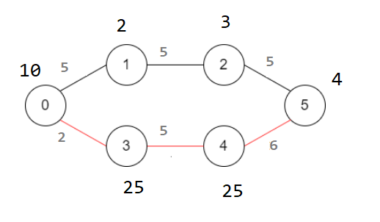

Input: edge= {{0,1,5}, {0,3,2}, {1,2,5}, {3,4,5}, {4,5,6}, {2,5,5}}

Charges = {10,2,3,25,25,4}

Source: 0

Destination: 5

Output: 64

Time Constraint=14 min

Note: the path 0, 3, 4, 5 will take minimum time i.e., 13 minutes and which costs around $64. We cannot take path 0,1,2,5 as it takes 15 min and violates time constraint which in 14 min.

**[5 Marks]**

**b)**

Assume you were hired to create an application for an ISP, and there is n number of network devices, such as routers, that are linked together to provides internet access to home user users. You are given a 2D array that represents network connections between these network devices such that a[i]=[xi,yi] where xi is connected to yi device.  Suppose there is a power outage on a certain device provided as int n represents id of the device on which power failure occurred)), Write an algorithm to return impacted network devices due to breakage of the link between network devices. These impacted device list assists you notify linked consumers that there is a power outage and it will take some time to rectify an issue. Note that: node 0 will always represent a source of internet or gateway to international network..

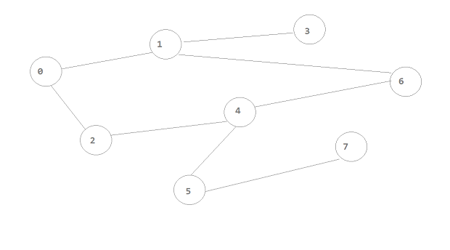

Input: edges= {{0,1}, {0,2}, {1,3}, {1,6}, {2,4}, {4,6}, {4,5}, {5,7}}

Target Device (On which power Failure occurred): 4

Output (Impacted Device List) = {5,7}

Explanation: power failure on network device 4 will disconnect 5 and 7 from internet

**[5 Marks]**

**Question 2**

**a)**

You are given a 2D array containing hierarchical information about certain species, with edge[i]=[xi,yi], where node xi is connected to xj. You are also provided an array of values associated with each species, such that value[i] reflects the ith nodes value. If the greatest common divisor of two values is 1, they are "relatively prime." Any other node on the shortest path from that node to the absolute parent node is an ancestor of certain species i. Return a list of nearest ancestors, where result[i] is the node i's nearest ancestor such that values[i] and value[result[i]] are both relative primes otherwise -1.

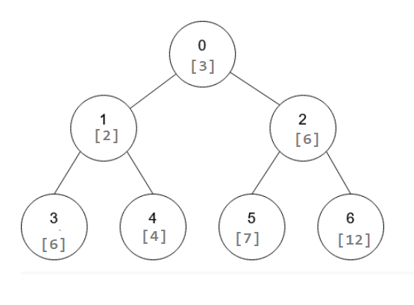

Input: values [3,2,6,6,4,7,12], edges= {{0,1}, {0,2}, {1,3}, {1,4}, {2,5}, {2,6}}

Output: {-1,0, -1, -1,0,2, -1}

**[5 Marks]**

**b)**

You are given an array of binary trees that represent different cities where a certain corporation has its branch office and the organization wishes to provide service by constructing a service center. Building service centers at any node, i.e., a city can give service to its directly connected cities where it can provide service to its parents, itself, and its immediate children. Returns the smallest number of service centers required by the corporation to provide service to all connected cities. Note that: the root node represents the head office and other connected nodes represent the branch office connected to the head office maintaining some kind of hierarchy.

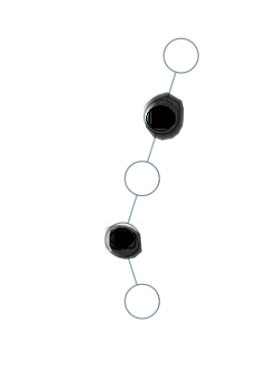

Input: tree= {0,0, null, 0, null, 0, null, null, 0}

Output: 2

Explanation: construction of two service centers denoted by black markk will be enough to provide service to all cities.

**[5 Marks]**

**Question 3**

**a)**

You are given an even length array; divide it in half and return possible minimum product difference of any two subarrays.

Note that the minimal product difference is the smallest absolute difference between any two arrays a and b, which is computed by calculating the difference after multiplying each element of the arrays a and b.

Input: {5,2,4,11}

Output: 2

{5,4} {2,11} result into minimum product difference.

**[5 Marks]**

**b)**

you are provided certain string and pattern, return true if pattern entirely matches the string otherwise return false.

Note: if pattern contains char @ it matches entire sequence of characters and # matches any single character within string.

Input: String a=“tt”, pattern =”@”

Output: true

Input: String a=“ta”, pattern =”t”

Output: false

Input: String a=“ta”, pattern =”t#”

Output: true

**[5 Marks]**

**Question 4**

1. Design and Implement LFU caching

**[5 Marks]**

1. Given a linked list containing an integer value, return the number of steps required to sort an array in ascending order by eliminating elements at each step

Note: at each step remove element a[i] where a[i-1]> a[i]

**[5 Marks]**

**Question 5**

a)

You are given a 2D array containing coordinates and height of rectangle such that height[i]=[xi,yi,hi], where xi the x coordinate of left edge, yi represents x coordinate of right edge of rectangle and hi represents the height of the peaks of each rectangle. If you want to construct a border line over the peaks of rectangle represented in bar chart, return the key coordinates required to build a border line that contacts the peaks of the given chart.

Note: key points are the left coordinates of shape representing peaks where you need to draw boarder line.

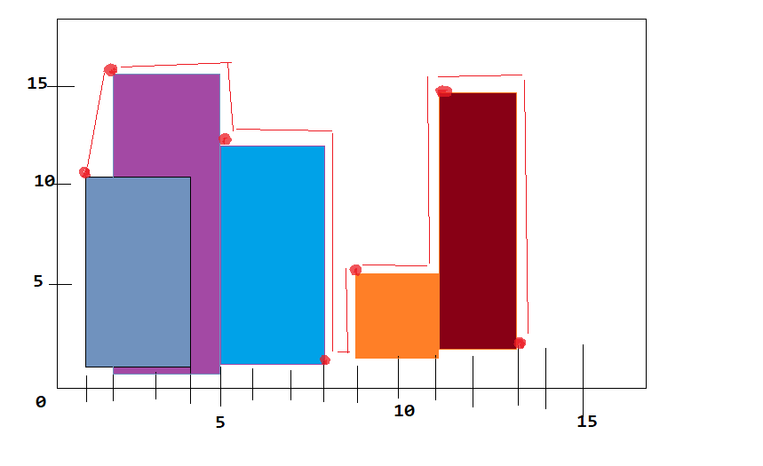

Input: height={{1,4,10},{2,5,15},{5,8,12},{9,11,1},{11,13,15}}

Output: {{1,10},{2,15},{5,12},{8,0},{9,1},{11,15},{13,0}}

**[5 Marks]**

**b)**

Assume an electric vehicle must go from source city s to destination city d. You can locate many service centers along the journey that allow for the replacement of batteries; however, each service center provides batteries with a specific capacity. You are given a 2D array in which servicecenter[i]=[xi,yj] indicates that the ith service center is xi miles from the source city and offers yj miles after the automobile can travel after replacing batteries at specific service centers. Return the number of times the car's batteries need to be replaced before arriving at the destination.

Input: serviceCenters = [{10,60},{20,30},{30,30},{60,40}], targetMiles= 100, startChargeCapacity = 10

Output: 2

Explanation: The car can go 10 miles on its initial capacity; after 10 miles, the car replaces batteries with a capacity of 60 miles; and after travelling 50 miles, at position 60 we change batteries with a capacity of 40 miles; and ultimately, we may arrive at our destination.

**[5 Marks]**

**Question 6**

1. Implement Huffman encoding and decoding.

**[5 Marks]**

1. You are given an array of different words and target words. Each character of a word represents a different digit ranging from 0 to 9, and no two character are linked to same digit. If the sum of the numbers represented by each word on the array equals the sum the number represented by the targeted word, return true; otherwise, return false. Note: Provided list of words and targeted word is in the form of equation

**Input:** words = ["SIX","SEVEN","SEVEN"], result = "TWENTY"

**Output:** true

**Explanation:**

s=6

I=5

X=0,

E=8,

V=7,

N=2,

T=1,

W=3,

Y=4

SIX +SEVEN + SEVEN = TWENTY

650 + 68782 + 68782 = 138214

**[5 Marks]**

**Question 7**

1. Implement multi-threaded algorithm to multiply n*n matrix.

**[5 Marks]**

1. Write multithreaded web crawler

**[5 Marks]**

**Question 8**

a**)**

Given 2D matrix of 1 and 0s. Using stack, find maximum area of square made by 0s.

INPUT: 1 0 1 0 0

0 1 1 1 1

0 0 0 0 1

0 0 0 1 1

0 1 0 1 1

OUTPUT: 4

**[5 Marks]**

**b)**

Given an array of even numbers sorted in ascending order and an integer k,

Find the k^th missing even number from provided array

Input a[] ={0, 2, 6, 18, 22} k=6

Output: 16 examples:

Explanation: Missing even numbers on the list are 4, 8, 10, 12, 14, 16, 20 and so on and kth missing number is on 6th place of the list i.e. 16

**[5 Marks]**

**Question 9 to 12**

Assume you've been recruited to create an application that aids in the batch processing of database operations. You must design a graphical user interface (GUI) application that allows you to add different jobs defined in the form of SQL procedures or functions and execute them in sequence. This task scheduling allows for the addition and execution of dependent tasks, parent tasks must be completed before child tasks. While developing this a workflow or task scheduling application, you can build application taking account of particular scenario of your choice for example implementation of batch processing or job scheduling required for financial and invoice calculation for sample consumers. Application must allow users to create their own profile.

* Application allow user to add tasks or jobs
* Application should allow user to define control flow of the jobs or create pipeline of the jobs
* Application should allow users to remove tasks
* Application should allow uses to resume tasks at position after sudden failure
* Parent tasks needed to be executed before executing child tasks.

**[20 Marks]**

**Total: [100 Marks]**

# Marking Notes

1. All submitted coursework will be assessed via VIVA conducted at the end of this semester.
2. Each VIVA will last 20 minutes.
3. You will submit on the deadline a document (PDF or Word) on Moodle containing all the coursework tasks solved and including a link to your GitHub Classroom repository shared via Softwarica LMS.
4. During the VIVA you will be assessed with a few relevant random questions.
5. If you submit only some of the tasks, your mark will be proportional to that.
6. The marking criteria valid for week 8-11 is presented below.

|  |  |  |  |  |  |  |
| --- | --- | --- | --- | --- | --- | --- |
| **Criteria** | 0 | 1 | 2 | 3 | 4 | 5 |
| **Feature complete (10)** | Not submitted | Only a few features implemented and are not executing | Many of the features are implemented but are not executing correctly | Many of the features are implemented and are executed correctly | Most of the features are implemented and are executed correctly | All features implemented and are executed correctly |
| **Code aesthetic (10)** | Not submitted | Assignment submitted but not commented and formatted. variable’s/classes/function are defined but meaningless | Lack of comments, formatted in Source code. Only a few classes and functions are defined but hard to read | Lack of comments, formatted in Source code, but meaningful variable/class/ function names are used few functions are defined. | Lack of comments, formatted in Source code, but meaningful variable/class/ function names are used. Code is easy to read | Source code is well commented, properly formatted, meaningful variable/function/class names are used. Code is easy to read and understand, having many pure functions. |
| **GUI (10)** | Not submitted | Hard to use. Only some components are used and unmanaged | Few frames are difficult to use. UI components are used but unmanaged. | Some frames are difficult to use. UI components are used but unmanaged. | Easy to use, Proper use of various UI components. User Interaction is low | Easy to use, Proper use of various UI components, Clean and interactive UI |
| **I/P Validation (10)** | Not submitted | Only a few input fields are validated. Error message are not shown | Only a few input fields are validated. Error messages are shown in code format | Most input fields are properly validated. Error messages are shown in code format | Most input fields are properly validated. Error messages are properly shown in natural language | All input fields are properly validated. Error messages are properly shown in natural language. |
| **Unit Testing (10)** | Not submitted | Only a few features are tested without using framework and many of them fail | Many of the modules are tested and many of them fail | Many of the modules are tested using suitable unit testing framework. | Most of the modules are tested using suitable unit testing framework. Should have partial coverage. | All modules are unit tested using suitable unit testing framework. Should have full testing coverage. |
| **Viva (10)** | Not present (Assignment submitted but absent in viva) | Could not explain the reasoning behind the code. But answered only one viva question | Could explain basic terms but not about algorithm. But answered only two viva question | Could explain reasoning behind the code, including use of loops, conditions, algorithms. answered only three viva question | Could explain reasoning behind the code, including use of loops, conditions, algorithms. answered only four viva question | Could explain reasoning behind the code, including use of loops, conditions, algorithms. Answered all five questions |